Minutes of the Meeting of Glapwell Parish Council, held on Thursday 23rd November 2023 in the Glapwell Centre, The Green, Glapwell.

**Members present:**

Cllrs T Trafford, C Fleetwood, J Ritchie and D Harvey

**Apologies:**

Cllrs P Clough, R Hibbert and I Grainger-Grimes

**In attendance:**

J Marriott (Responsible Finance Officer)

Dr J Clarke (Parish Clerk)

**Public Participation**

1 member of the public attended.

**BUSINESS**

**Public speaking**

Liam Wajs spoke from Glapwell Football Club about the club’s plans to develop new teams

and a kickstart scheme for 4-6 year olds.

**01/11/23 Apologies for absence**

Apologies were received from Cllrs P Clough, R Hibbert and I Grainger-Grimes

**02/11/23 To receive declarations of interests**

Cllrs Trafford and Fleetwood declared a personal interest as Trustees of the Glapwell Guardians.

All councillors present declared a personal interest in the Glapwell Community Sports Association.

Cllr Ritchie declared a personal interest in Glapwell Cricket Club.

**03/11/23 Minutes**

**RESOLVED That:** these minutes were approved as an accurate record of the meeting held on 26th October 2023.

**04/11/23 Exclusion of Public**

None

**05/11/23 Reports**

1. **Parish Clerk’s report**

The Clerk’s report concentrated on the roof. The council has secured a loan for the repairs which will be done by Blue Lines in January 2024. The sports hall boiler has also been replaced. There has also been a successful grant for kitchen equipment.

1. **District Councilor’s report**

Cllr Ritchie reported on the District Council’s successful bed for £15 m of Leveling Up Funds for Bolsover town centre.

1. **County Councilor’s report**

Cllr Barron was not present.

1. **Police Report**

No report had been submitted.

1. **Glapwell Centre Manager’s report**

The Manager’s report concentrated on the cash income for the Guardians and the Sports ground.

**06/11/23 Planning**

Application No: 23/00546/FUL Decision Level: Delegated

Proposal: Construction of a gazebo to the rear of the property incorporating a covered garden storage area to the side of the property.

Location: 16 The Pinfold Glapwell Chesterfield S44 5PU

Applicant: Mr Ben Charlton

Resonse: No objection

Application No: 23/00539/FUL Decision Level: Delegated

Proposal: Erection of large dog kennel to the rear garden.

Location: 13 Park Avenue Glapwell Chesterfield S44 5PZ

Applicant: Mrs B Joyce

Response: Object. Inappropriate to commercially breed dogs in a residential setting.

Application No: 23/00536/FUL Decision Level: Delegated

Proposal: Erection of public art and associated landscaping

Location: Glapwell Nurseries Glapwell Lane Glapwell Chesterfield

Applicant: Meadowview Homes

Response: Lack of public consultation. With parish. Not suitable location for public art and what is proposed isn’t really art. No adequate community consultation. Monies could go to the Pleasley – Glapwell- Doe Lea Cultural Corridor.

Application No: 23/00488/FUL Decision Level: Delegated

Proposal: Raising height of fence to rear to 2.41m

Location: 6 The Hill Glapwell Chesterfield S44 5LY

Applicant: Mr Andre Fisher

**07/11/23 Items for Consideration and Decision**

- **Renovation of the community centre (standing item).** The architect had revised some drawings for the Community Hall and a quantity surveyor had produced an estimate of the costs involved to rebuild the centre. These had come in around £1.5 million. As agreed at the March 2023 meeting, the architect’s costs were approximately £900 and the Quantity Surveyor’s £700.

- **The football ground and MUGA (standing item).** Hall Corner has been closed die to the inclement weather. The MUGA would be closed when temperatures hit freezing.

Wednesday Wanderers had offered to do some voluntary work on the football ground. Cllr Fleetwood would liaise with them and bring a report back to the January 2024 parish meeting.

- **Notice boards.**  A member of the public had requested that the two noticeboards not outside the centre were replaced. The councillors suggested a couple of places where they might be procured locally.

**Lease of cricket ground.** The clerk had enquired into the cost of a lease and had been told £1250-1500. The Chair said the parish had already partially paid for a lease agreement for the football ground, and asked if this could be adapted for the cricket ground to save money.

**RESOLVED That:** the Clerk would make enquiries with regards to the noticeboards ans the cricket ground lease.

**08/11/23 Items for Information Only**

1. **Correspondence**

None received

1. **Items for Information**

None received

**09/11/23 Finance**

1. Payments for authorisation

Council received the list of payments for authorisation for approval.

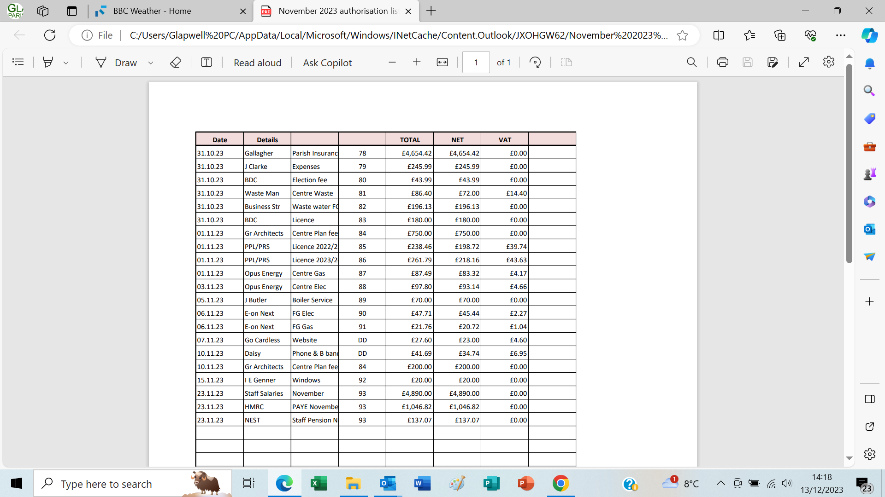

1. Income and expenditure, bank reconciliation

The Responsible Financial Officer presented the Income and Expenditure Account for October 2023 and bank reconciliation as at that date.

1. Budget

The precept was set at £130,000 due to the need to repair the roof and replace the sports hall boiler.

1. NALC pay rise

The national pay rise was noted and it was agreed to back pay the award from April 2023.

The Chair thanked the Clerk and the RFO for the work they had done in preparing the Budget.

**Resolved that:** these are received and approved

**10/11/23 Items to be included on the next agenda (Thursday 25th January 2024)**

None. The Clerk reported that she would be on leave 5th – 22nd January 2024 and that the agenda would go out early with reports to follow in the week of the meeting.

**Meeting closed at 9.03 pm**

**Chair:_________________________________________ Date:________________________**